Statement of Work

## Summary

A statement of work suitable for a contract issued in the course of a pilot project with an annotation service

The Laboratory of Cellular Imaging and Macromolecular Biophysics (LCIMB), part of the National Institute of Biomedical Imaging and Bioengineering (NIBIB) wants to know if time-consuming image annotations for microscopy computer vision machine learning projects can successfully be outsourced to commercial image annotation providers.

We plan to issue a “data challenge” as a pilot project, giving each provider a standardized dataset, annotation evaluation criteria, and vendor evaluation criteria in order to ascertain which vendors are capable of producing future new annotations for LCIMB or other interested labs within the NIH.

## Objective

Determine the efficacy of annotation outsourcing services for the segmentation of biological electron microscopy images. Image data will be provided by LCIMB, and annotations created by providers will be compared against ground truth annotations created by experts within LCIMB and collaborating labs.

## Scope

The creation of instance and/or semantic segmentation annotations for provided image data, after annotators have been trained on the task using existing annotations from a similar dataset. Created annotations will be evaluated against in-lab annotations for quality.

## Data

### Image Data

The image data consists of two 3D images of human platelets acquired by a serial block-face scanning electron microscope (SBF-SEM). This data has been cleared for public release. All files use a uint16 multipage TIF format. A 3D image with size [Z, X, Y] is saved as Z pages of size [X, Y]. SBF-SEM image volumes are acquired as a series of *x-y* cross-sections along a depth axis *z*. These *x-y* cross-sections are called *lateral views*, and form the 2D images a user interacts with on-screen. Image voxels are approximately 40x10x10 nm^3.

**1**. **unlabeled-images.tif**: Size [50, 800, 800]. The project objective is to create one or more labelings of this dataset.

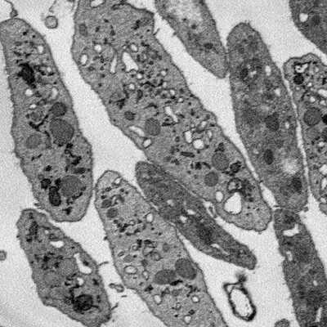

Page 0 of *unlabeled-images.tif*

**2**. **labeled-images.tif**: Size [24, 800, 800]. In addition to the image data, we provide a *labels* folder which contains semantic and instance segmentations of *labeled-images.tif*. The label data can be used for, e.g., learning labeling tasks, quality control, and illustration.

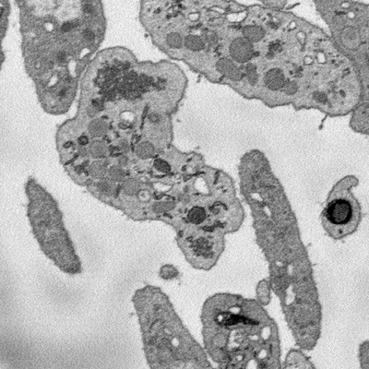

Page 0 of *labeled-images.tif*

#### Additional Image Data

If all chosen labeling tasks for the provided image are finished before the end of the project, there are additional similar image datasets that can be provided. All other things being equal, producing labels for a larger amount of data is a project preference.

## Labels

The project objective is to produce one or more label files from the *unlabeled-images.tif* image volume, assigning semantic or instance labels to cells and organelles within the image. Each produced label file should be saved as a uint16 multipage TIF, indexed or RGB. Label files should be saved as Z pages of size-[X, Y] lateral views.

### Definitions

*Membrane*: A barrier between a biological structure and its external environment. In the provided SBF-SEM images, *membrane-bound* objects have a border which is darker than the neighboring object interior.

*Cell*: Membrane-bound biological matter. Effectively, any image region darker than the background.

*Organelle*: A closed structure contained within a cell. Cells have multiple types of organelles. All organelles of interest to this project are membrane-bound. Effectively, a closed region inside a cell.

### Semantic labels

Semantic labels are image masks that classify each image voxel into one of six classes, indexed from 0 - 5:

|  |  |
| --- | --- |
| **Index** | **Class name** |
| 0 | Background |
| 1 | Cell |
| 2 | Mitochondria |
| 3 | Alpha granule |
| 4 | Canalicular vessel |
| 5 | Dense granule |

*Note*: Human labelers require 3D spatial context to resolve semantic label ambiguity and object boundary ambiguity in 2D image windows.

**0**. **Background**: Image regions containing no live biological material. Mostly background, occasional dead cell fragments.

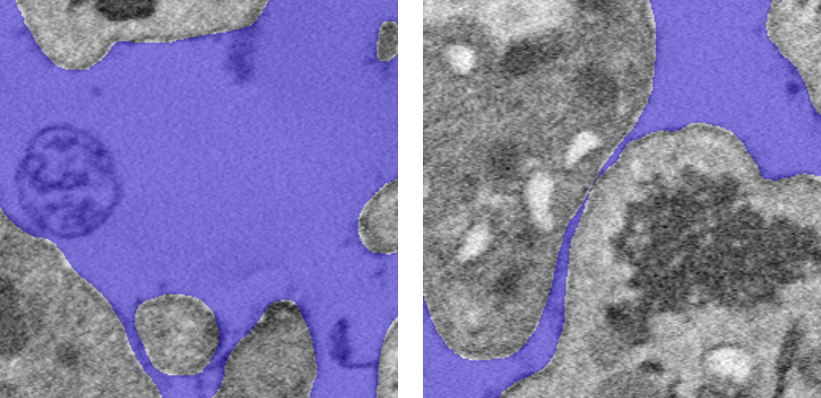

**1**. **Cell**: Live cellular material - membrane, cytoplasm, and all organelles. Technically excludes the organelle regions indexed by 2-5, but full-cell masks are easier to produce.

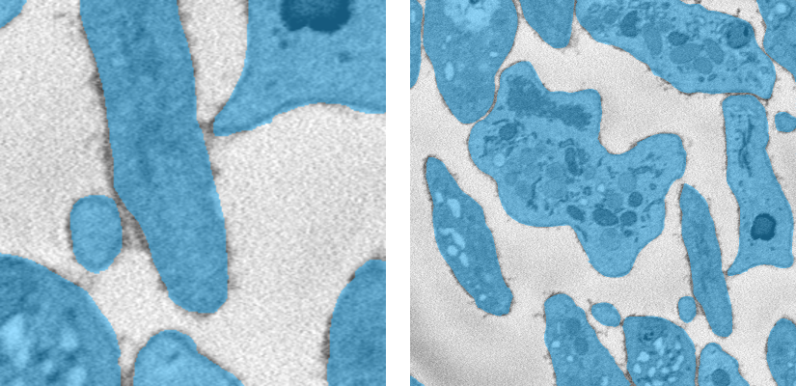

**2**. **Mitochondria**: The darkest-colored organelle. Compare with the slightly lighter alpha granules.

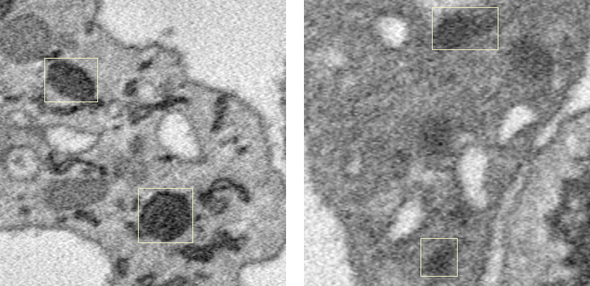

**3**. **Alpha granule**: Another dark-colored organelle. A little lighter than mitochondria.

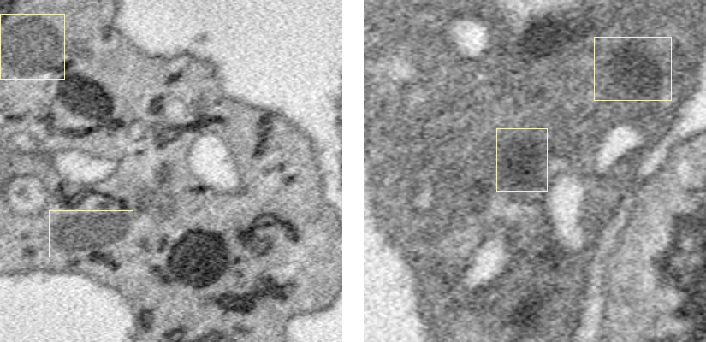

**4**. **Canalicular vessel**: A light-colored organelle, with interior about the same color as the background. Compare with dense granules, which are also light-colored but contain dark-colored cores.

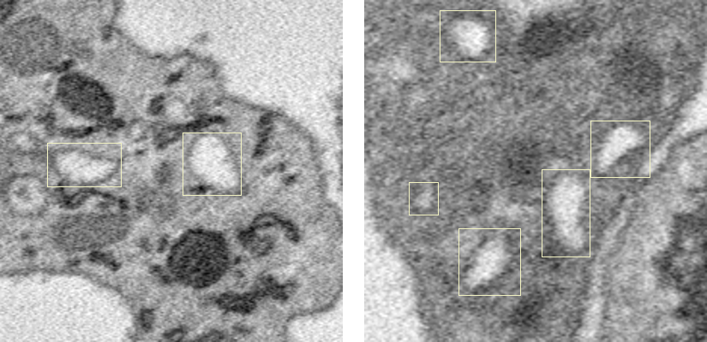

**5**. **Dense granule**: An uncommon, light-colored organelle with a dark core.

*Note*: If no core is present in a given 2D image window, the 2D dense granule cross-section may be impossible to distinguish from a canalicular vessel cross-section.

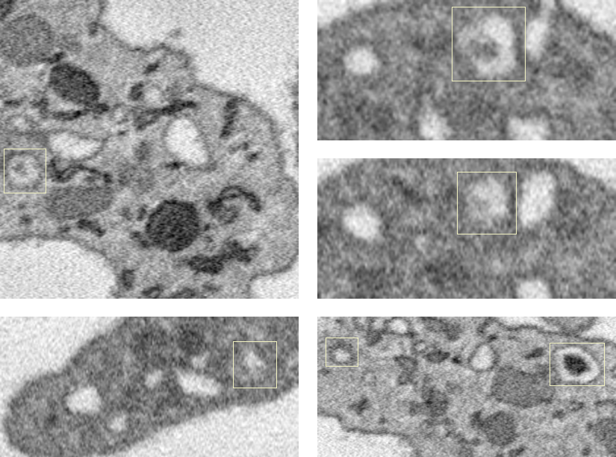

### Instance labels

Instance labels are image masks which assign a unique tag to the voxels within each distinct object of interest in an image volume. Instance labels may be created in 2D or 3D. Since organelles are contained within cells, labels are stored in two separate datasets - cell instance labels, and organelle instance labels. In total there are four instance label datasets: 2D cell, 2D organelle, 3D cell, 3D organelle.

**2D instance labels**

Tags are assigned to distinct object cross-sections within 2D image windows. Tags for cross-sections of the same 3D object are not linked between different 2D image windows.

**3D instance labels**

Tags are assigned to distinct objects within the entire 3D image volume. Tags for cross-sections of the same 3D object are the same between different 2D image windows.

**Example: 2D and 3D cell instances**

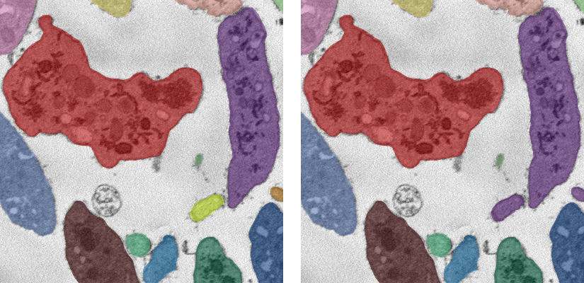

(Left) 2D cell instance labels. (Right) 3D cell instance labels. Note the differences on the right side of each image - three 2D cross-sections (purple, orange, yellow) belong to the same 3D cell (purple).

**Example: 2D and 3D organelle instances**

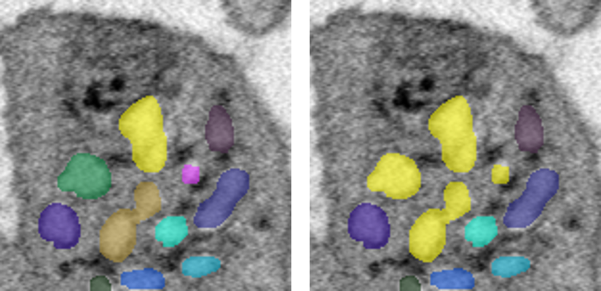

(Left) 2D organelle instance labels. (Right) 3D organelle instance labels. Four 2D cross-sections (yellow, pink, orange, green) belong to the same 3D canalicular vessel (yellow).

## Annotation Tools

Annotations will be created using Onepanel (<https://onepanel.io>).

## Cost

A budget of $10,000 has been allotted for annotation tasks. Vendors should continue generating annotations until the $10,000 threshold has been reached, or all available data has been annotated, whichever comes first. Quotes should be defined as a cost per-unit work, whether that is per image, per hour, etc.

## Time Frame

The project should take no more than three months.

## Acceptance of Work

As this is a pilot, work acceptance requires only that one or more label files be produced and submitted back to LCIMB. Those label files will be evaluated to determine if they are of sufficient quality for annotation outsourcing to be viable for future scientific research projects. There are two aspects to this evaluation: label KPIs and vendor KPIs.

### Label KPIs

**Instance labels**: Same whether in 2D or 3D, cell or organelle. Count split errors and merge errors, and also create a list of per-tag intersection-over-union (IOU) scores.

**Semantic labels**: If semantic labels are produced as well, assign a class to each object instance equal to the class that the majority of the instance's pixels belong to. Count each misidentification as an error. Additionally, we will produce a per-class IOU confusion matrix to get a better idea of accuracy, but this will not be a KPI.

### Vendor KPIs

**Label types produced**: There are a number of possible combinations of labels that can be produced in this project. 3D is preferred over 2D, instance + semantic is preferred over instance alone. A complete instance label submission must contain both a cell instance label file and an organelle instance label file.

**Labeling time**: In a given unit of time, how many labeled images are produced? For reference, in-lab annotation for one label type (instance, semantic) takes ~15-20 minutes per 800x800 lateral view. All other things being equal, prefer less time taken over more time.

**Number of labels produced**: How many image labels are produced within the $10,000 budget?

[**TODO**]: Figure out if we want something in here about vendor “quality” - how communicative they are, how responsive they are to problems that arise, anything else?

## Project Management

[**TODO**]: Do we need this section? Detail what we expect in terms of vendor project management structure and who we correspond with over the course of the project?